**Step 1: Connect to Azure Cloud Shell**

1. Go to the [Azure Portal](https://portal.azure.com).

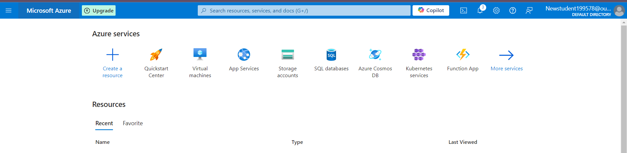

1. Click on the **Cloud Shell** icon (a terminal icon) at the top-right corner of the portal.

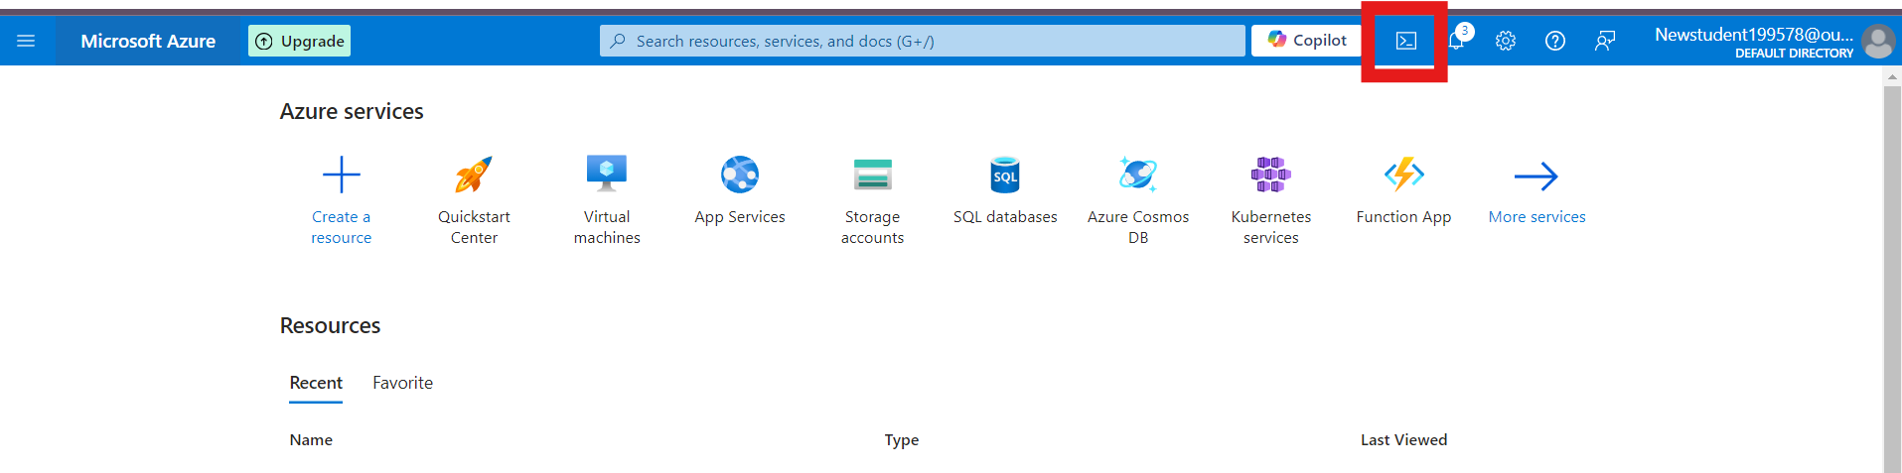

1. Select **PowerShell**.



1. The Cloud Shell will automatically connect to your Azure environment.

**Step 2: Create a Resource Group**

Once inside Cloud Shell:

**PowerShell:**

1. Run the following command to create the resource group:

**New-AzResourceGroup -Name "rg-1" -Location "South Central US"**

**1. Create 3 Storage Accounts with “Team” Tags**

# Create Storage Account for Team 1

**az storage account create --name shahidteam1 --resource-group rg-1 --location "South Central US" --sku Standard_LRS --tags team="team1"**

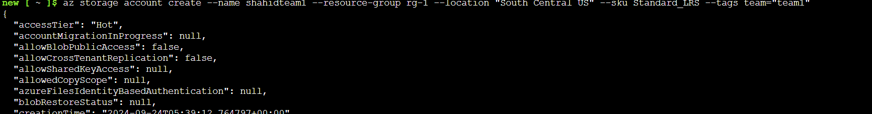

# Create Storage Account for Team 2

**az storage account create --name shahidteam2 --resource-group rg-1 --location "South Central US" --sku Standard_LRS --tags team="team2"**

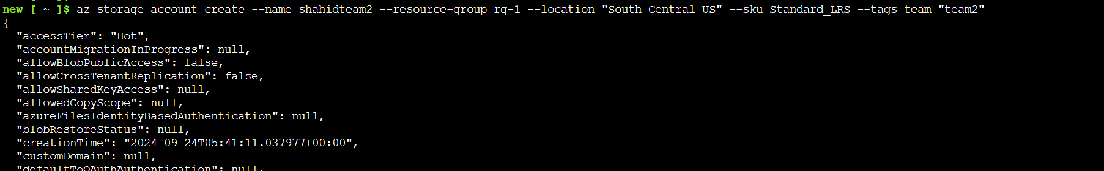

# Create Storage Account for Team 3

**az storage account create --name shahidteam3 --resource-group rg-1 --location "South Central US" --sku Standard_LRS --tags team="team3"**

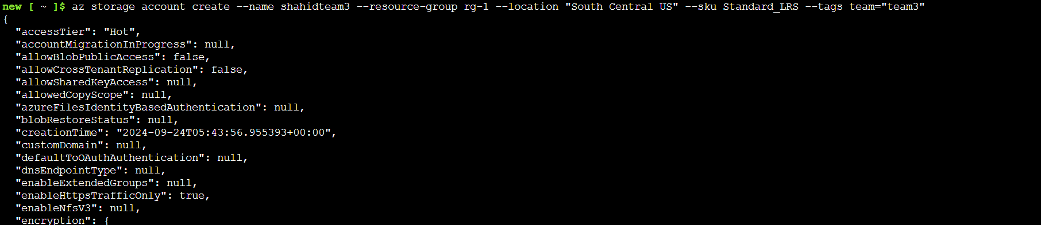

**2. Create One More Storage Account for Team 2**

**az storage account create --name shahidteam2additional --resource-group rg-1 --location "South Central US" --sku Standard_LRS --tags team="team2"**

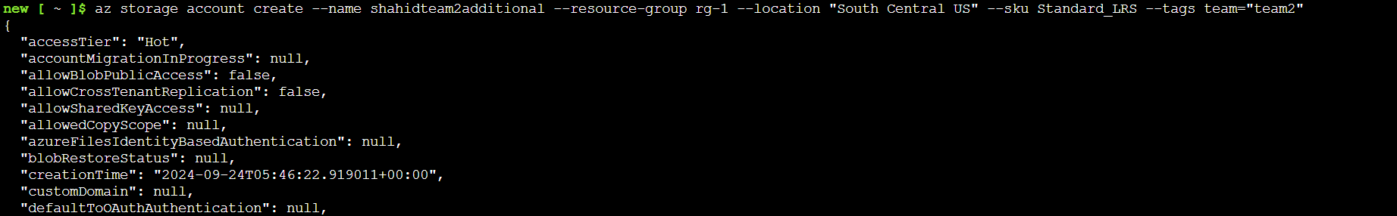

**3. List All Resources for Team 2 Using Tags**

**az resource list --tag team="team2" --output table**

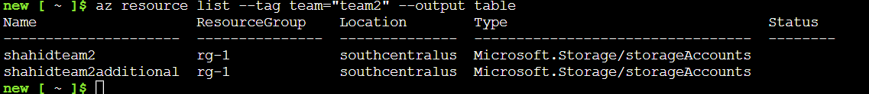

**1. Create a File Share**

Use the following command to create a file share:

**az storage share create --name shahidteam1fileshare --account-name shahidteam2**

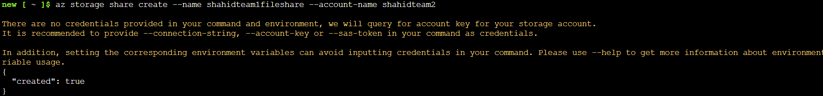

**2. Mount the File Share on Windows**

**Step 1: Install Azure Storage Explorer**

You can use Azure Storage Explorer or the built-in Windows features to mount the file share. Here’s how to do it using Windows Explorer:

**Step 2: Mounting the File Share**

1. Open **File Explorer**.
2. Click on **This PC**.
3. Click on the **Computer** tab and then select **Map network drive**.

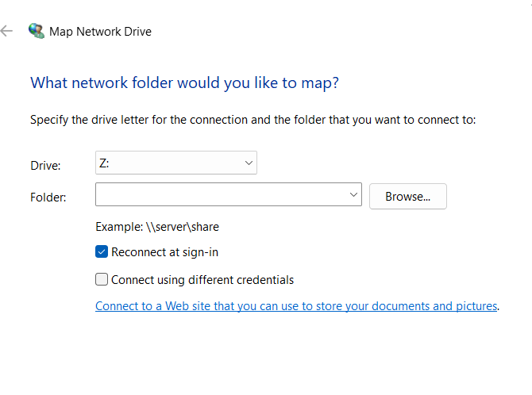

1. Choose a drive letter (e.g., Z:).
2. In the Folder box, enter the following:

\\**shahidteam2.file.core.windows.net\shahidteam1fileshare**

1. Click on **Connect using different credentials**.

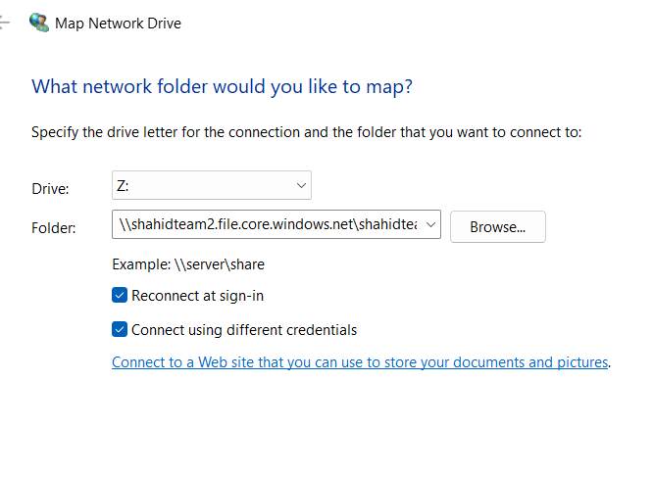

1. For the username, enter:

**Azure\shahidteam2**

1. For the password, use a storage account key, which you can get by running:

**az storage account keys list --account-name shahidteam2 --query "[0].value" --output tsv**

1. Click **OK** to mount the drive.

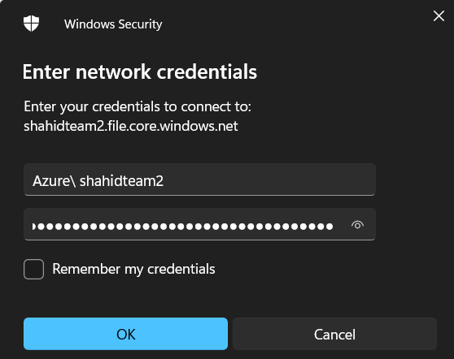



**3. Mount the File Share on Linux**

**Step 1: Install cifs-utils**

You need to have cifs-utils installed. You can install it using the following command:

For Ubuntu:

**sudo apt update**

**sudo apt install cifs-utils**

**Step 2: Create a Mount Point**

Create a directory to mount the file share:

**sudo mkdir /mnt/shahidteam2**

**Step 3: Mount the File Share**

Use the following command to mount the file share:

**sudo mount -t cifs //shahidteam2.file.core.windows.net/shahidteam1fileshare /mnt/shahidteam2 -o vers=3.0,username=shahidteam2,password=<password>',dir_mode=0777,file_mode=0777,sec=ntlmssp**

